Hiyab Mengisteab

Data Preparation Task 2

Column Name | Data Type
age | Continuous
sex | Categorical
bmi | Continuous
children | Continuous
smoker | Categorical
region | Categorical
charges | Continuous
Level | Categorical
score | Continuous

Import and Read Excel file:
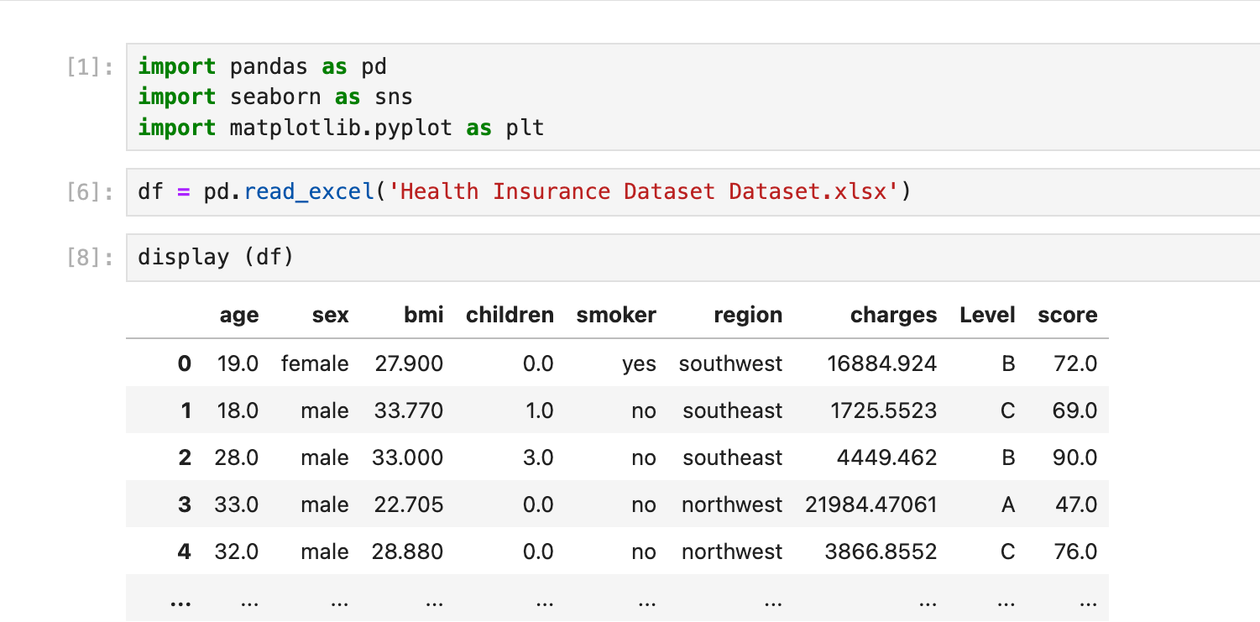

- Continuous Variables: age, charges
- Categorical Variables: sex, region

PART A: UNIVARIATE STATISTICS

Continuous/ Categorical | Variables | Code & Visualization
Continuous | Histogram of Age | 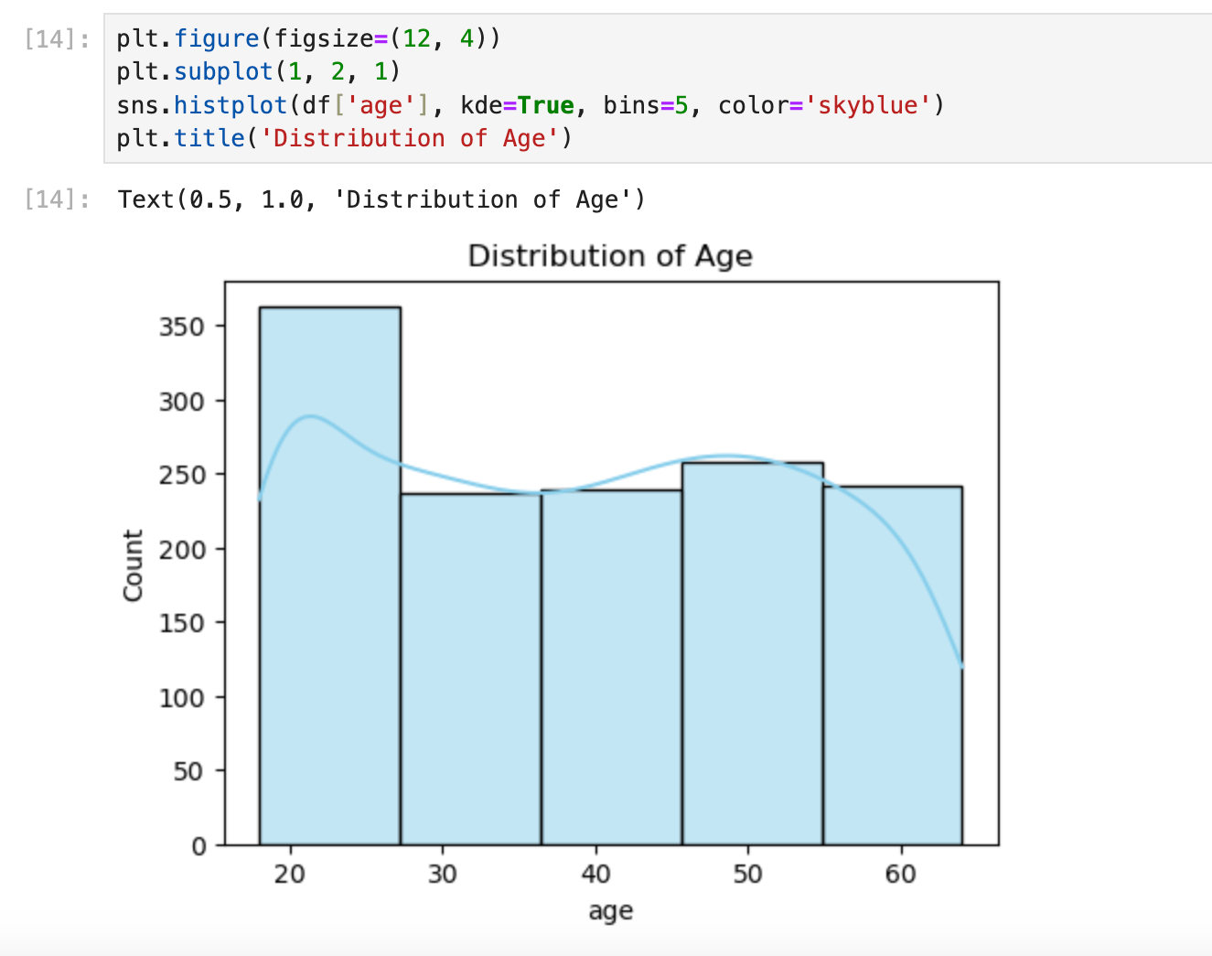
Continuous | Histogram of Charges | 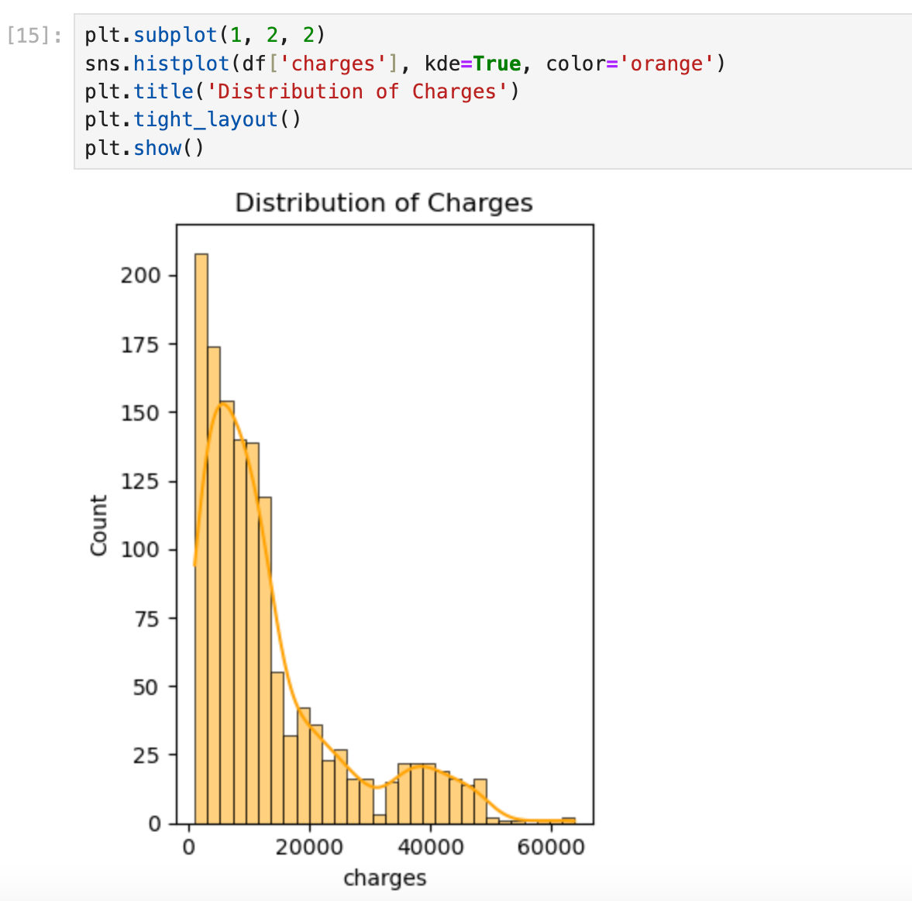
Categorical | Barplot: Sex | 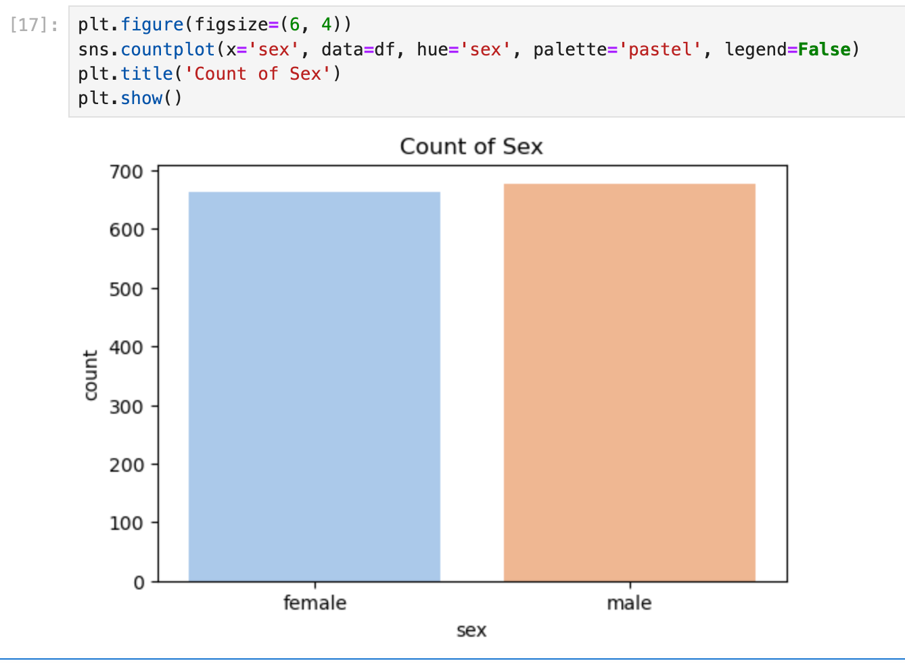
Categorical | Barplot: Region | 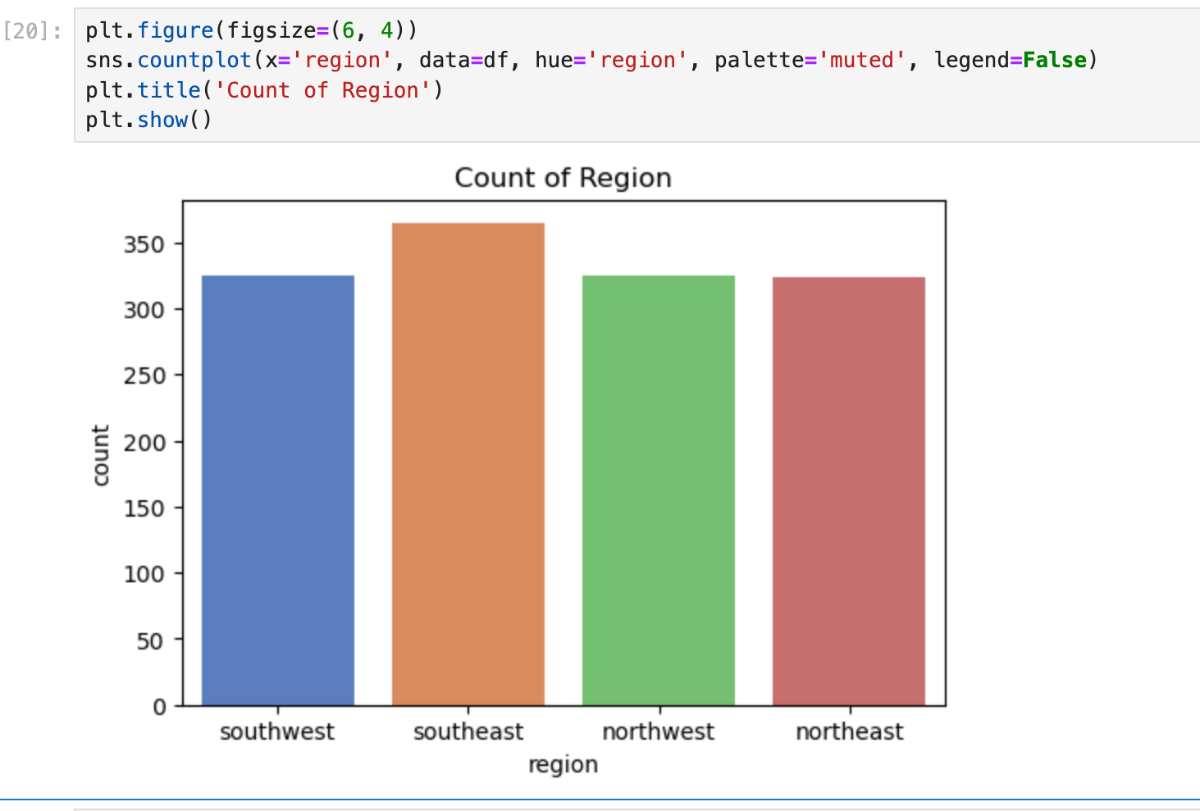

PART B: BIVARIATE STATISTICS
=

Continuous/ Categorical | Variables | Code & Visualization
Continuous - Correlation between Age and Charges | Scatterplot: Age vs. Charges | 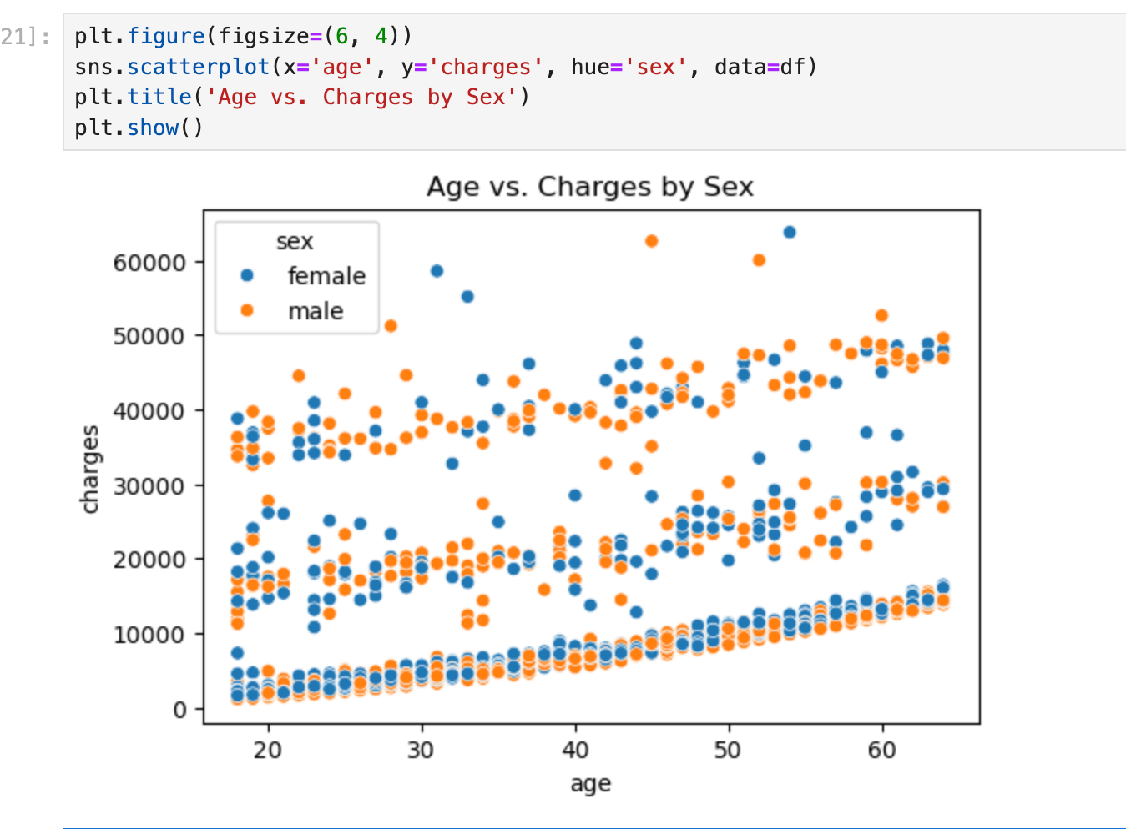
Categorical – count of Sex by Region | Countplot: Sex vs. Region | 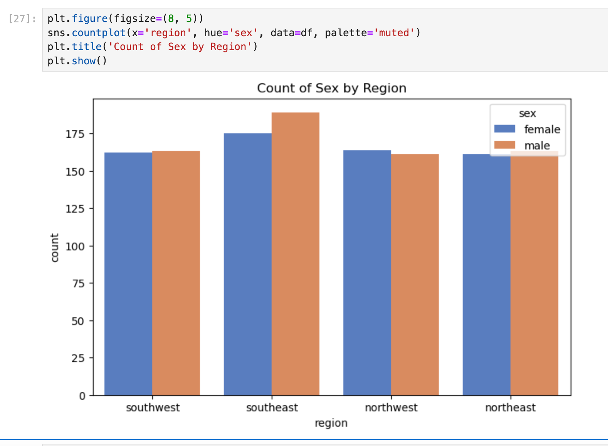

C. Real-World Organizational Situation
C1. Research Question:
- Does smoking status have a statistically significant impact on insurance charges? This is important for insurance companies to price policies fairly and assess risk factors accurately.
C2. Relevant Variables:
- Independent Variable: smoker (categorical: yes/no)
- Dependent Variable: charges (continuous)

D. Parametric Test Analysis
D1. Chosen Parametric Test:
- Independent Samples t-test: Used to compare the means of two independent groups (smoker vs non-smoker) on a continuous variable (charges).
D2. Hypotheses:
- Null Hypothesis (H₀): There is no difference in average charges between smokers and non-smokers.
- Alternative Hypothesis (H₁): Smokers have higher average charges than non-smokers.

D3. Python Code (Parametric Test):

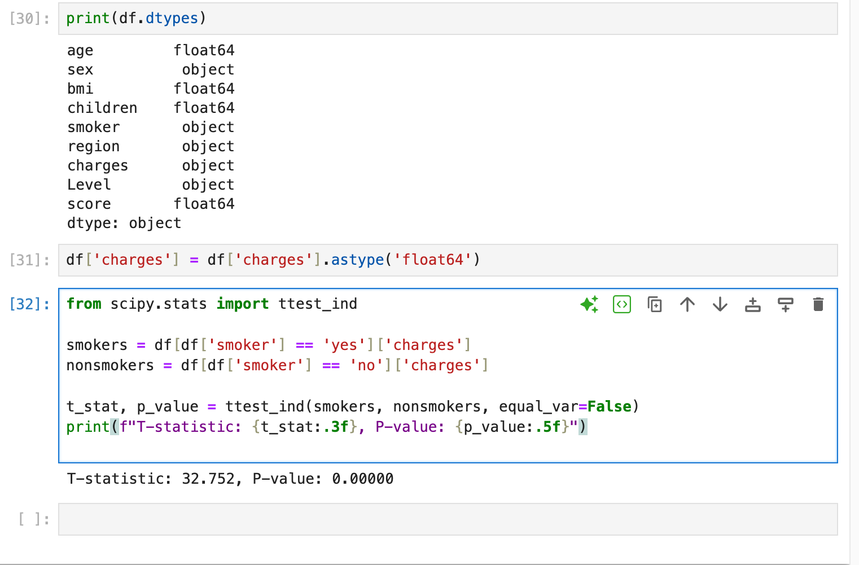

D4. Sample Output:
- P-value is < 0.05 – This would strongly support the idea that being a smoker is associated with higher insurance charges.

E. Evaluation of Parametric Test

E1. Justification:
- The t-test is appropriate because the dependent variable (charges) is continuous. And the independent variable (smoker) is binary categorical. This would mean that we’re comparing the means of two groups.

E2. Test Result:
- Since p < 0.05, we reject the null hypothesis. There is a significant difference in charges between smokers and non-smokers.

E3. Stakeholder Benefits:
- Insurance providers can use this finding to adjust premium pricing for higher-risk individuals. And potentially provide discounts for non-smokers.

F. Implications of Parametric Test

F1. Answer to Research Question:
- Smoking status significantly affects insurance charges. Smokers pay higher premiums.

F2. Limitations:
- Small sample size. This data also assumes normal distribution and equal variance. Additionally, this doesn't control for other variables like age or region.

F3. Recommended Action:
- Implement targeted premium adjustments and health interventions for smokers.

F4. Code Submitted: (See D3)

G. Real-World Organizational Situation

G1. Research Question:
- Is there an association between insurance level (Level) and region? This helps insurance companies identify regional risk trends and resource allocation.

G2. Relevant Variables:
- Level (categorical: A, B, C)
- Region (categorical: southeast, southwest, etc.)

H. Nonparametric Test Analysis

H1. Chosen Nonparametric Test:
- Chi-Square Test of Independence

H2. Hypotheses:
- Null Hypothesis (H₀): Insurance level is independent of region.
- Alternative Hypothesis (H₁): Insurance level is associated with region.

H3. Python Code (Nonparametric Test):

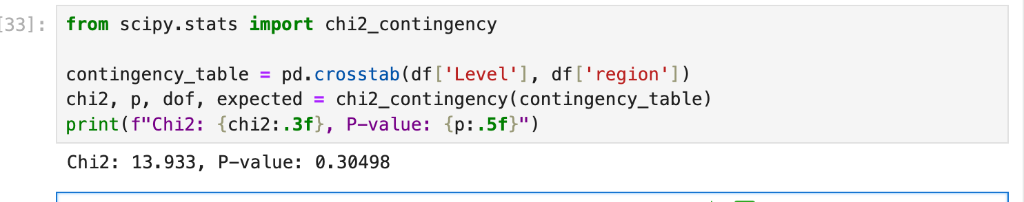H4. Sample Output:


I. Evaluation of Nonparametric Test

I1. Justification:
- Chi-square test is appropriate because both variables (Level, region) are categorical. We want to test association, not mean differences.

I2. Test Result:
- Since p > 0.05, we fail reject the null hypothesis. Based on the data, there's no statistically significant evidence to suggest that insurance level is associated with region.

I3. Stakeholder Benefits:
- Insurers don’t need to adjust offerings based on region. They can standardize offerings across regions without fearing regional bias

J. Implications of Nonparametric Test

J1. Answer to Research Question:
- Insurance levels do not vary significantly by region.

J2. Limitations:
- Small sample size may distort chi-square test.
- Doesn’t explain causation—only association.

J3. Recommended Action:
- Confidence that region can be excluded from predictive models for insurance level — simplifying models and improving efficiency.

J4. Code Submitted: (See H3)

Reference:
- External resources not used in this submission

